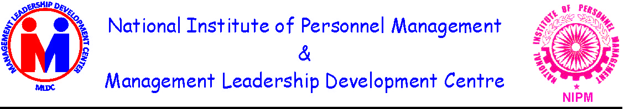
Dr. Jauhari Lal R.P. Singh
President Chairman
Former Director (HR), ONGC National Institute of
Former Director (Per.), OIL Personnel Management
Former National President, NIPM (Delhi Chapter)
Former Secretary General PETROTECH Director (HR) IFFCO

Workshop
on
“Medical and Emergency Needs of Retired Employees of CPSEs – Creation of Corpus”
on 16th November, 2010 at SCOPE Complex, New Delhi

Proceedings of the Workshop

National Institute of Personnel Management and Management & Leadership Development Centre organized a one day workshop on “Medical and Emergency Needs of Retired Employees of CPSEs – Creation of Corpus”. The following distinguished speakers addressed the workshop:-

- Dr. Nitish Sen Gupta, Chairman, BRPSE, Government of India.
- Dr. U.D. Choubey, Director General, SCOPE & Former CMD, GAIL.
- Shri Rajendra Kumar, Director, DPE, Government of India.
- Shri K.Ramachandran Pillai, CMD, National Textile Corporation Ltd.
- Dr. A.K. Balyan, MD, Petronet LNG and Former Director (HR), ONGC.
- Shri R.S.Butola, MD, ONGC Videsh Ltd.
- Shri G.L.Tandon, Former CMD, Coal India Ltd & Neyveli Lignite Corporation Ltd.
- Shri B.K.Bakshi, Former CMD, Indian Oil Corporation Ltd.
- Shri R.Srinivasana, Former Member (Per), ONGC.
- Shri R.P. Singh, Director (Per), IFFCO.
- Shri Neeraj Jain, IFFCO Tokyo Gen. Insurance Company.
- Dr. Jauhari Lal, President, MLDC & Former Director (HR), ONGC & OIL.
- Ms. Jatinder Peters, Vice Chairperson, NIPM (Delhi Chapter) & GM, ONGC.
The following presentations were made:-
- Shri M.B.Aparajit, Chief Manager, CIL.
- Shri S.K.Singh, EA to Director (HR), OIL.
- Ms. S. Swaminathan, Sr. Manager (HR), BHEL.
- Shri A.K.Shah, GM (HR), ONGC.
- Shri S.C.Mahato, Sr. Manager, GAIL.

60 executives from 18 organizations attended the workshop which included 10 retired executives from CPSEs. S/Sh. A.S.Soni, Former Director (Offshore), ONGC and Shri Ashok Anand, Former Director (Per), Oil India Ltd also attended it. The workshop was divided into 4 sessions i.e. 2 sessions before lunch and 2 sessions in the afternoon.

2. Dr. Jauhari lal, President MLDC and Former Director(HR), ONGC & Oil India Ltd. brought out briefly the objectives of the workshop as follows:-

- Understand the provisions and implications of the DPE guidelines issued vide their Office Memorandum No.2 (81)/08-DPE (WC)-GL-XVI/ 2009 dated 8 July 2009.
- Sharing of information by PSUs on the status of implementing the above guidelines.
- Options available to PSUs for medical facilities to retired employees.
- Understanding “emergency needs” of retired employees as stipulated in the guidelines.
- Formation of a model Scheme for creation of corpus.
- Strategy for honoring the DPE guidelines.

3. Shri Rajendra Kumar, Director, DPE made a presentation on “Welfare Steps for Retired Employees of CPSEs”. In his presentation he brought out the following points:-

- 2nd pay revision committee met retired CPSEs executives including the All India Non-Pensioned Cum Senior Citizens Retirees’ Association, Bangalore.
  - The committee observed that while a few CPSEs provided post retirement medical benefit, most of the retired executives had no access to medical benefits.
  - Committee recommended up to 30% of basic pay towards superannuation benefit after providing for PF and gratuity a buffer available for pension and/or post retirement medical benefits. This was available only for those who superannuated after 15 years of service in a CPSE.
  - Corpus from 1 to 1.5% of PBT be created by CPSEs for medical and any other emergency needs for retired executives and also those who were not adequately covered by a pension scheme.

4. He further pointed out that the recommendations of the committee were circulated and suggestions were sought regarding feasibility and methodology of operationalising them. However DPE could receive only two responses without any specific comments. Subsequently these guidelines were issued. Creation of corpus was provided for benefit of those who had no support system like pension or medical benefit scheme. However for those retiring after 01.01.07, superannuation benefits up to 30% of basic pay + DA was provided which included CPF, Gratuity, Pension and Post Superannuation medical benefits. He further stated that CPSEs should make their own schemes to manage the fund or to operate through insurance companies.

5. With regard to OM dated 8th July, 2009, Shri Rajendra Kumar clarified that the schemes were to be formulated only where need was felt to take care of medical and any other emergency needs for those not covered by the pension scheme and / or post superannuation medical benefit scheme. Guidelines provided that not more than 1.5% of the PBT of previous year and even may be less depending on requirement to be earmarked for creating the corpus. Guidelines further provided for constituting a committee of Directors for deciding on distribution of funds and identifying areas of medical and emergency needs. However, there would be no budgetary support from the Government. The CPSEs would submit their proposals of the scheme to their respective Ministry/Department for approval. Sh.Rajendra Kumar mentioned that as per his knowledge, no CPSE had framed any scheme. However, some CPSEs had started framing the scheme to replace / supplement the existing scheme and they were considering paying a monthly amount to meet medical and emergency needs. He further clarified that the intention should not be to exhaust the funds but to provide for a reasonable support for medical or emergency requirements and the contribution might be flexible depending upon the CPSEs PBT.

6. Dr.Nitish Sen Gupta Chairman, BRPSE, Secretary to Govt. of India (retired) and Former M.P. and Director, IMI who was the Member of the 2nd PRC mentioned about his experiences of meeting the representatives including the retired employees of the CPSE’s. He admitted that the plight of a large number of retired employees was really pitiable. The committee was moved after listening to their woes and made these recommendations. He further mentioned that the recommendations of this PRC were quite different from the past PRC’s. It brought the culture of compensation linked with profitability of an organization and de-linked from the Govt. pay scale structure. The recommendations of medical benefits to the retired employees were also unique. He felt sorry that no CPSE had formulated the scheme as per DPE guidelines. He said these were very important guidelines and emphasized that the money was not a constraint is a will, there is a way” and these guidelines were to be read between the lines and with the right spirit. He suggested that companies should get together and evolve suitable systems. He emphasized that there was urgent need that DPE should ensure that these guidelines were implemented. He suggested that this issue needed to be taken to the level of Secretary, DPE and even with the Honorable Minister.

7. Dr.U.D. Choubey DG, SCOPE and former CMD, GAIL in his special address traced the history of formation of Public Sector undertakings and its concept. These were created basically to modernize the process of industrialization of Indian economy in its various facets and also to reach the remotest and the most backward areas of the country for development. These were called as “Commanding heights and Modern temples of India”. The PSUs had made major contribution in the socio-economic development of the Country. PSUs at one time had 24 lakh employees which reduced to 15 lakh at present. It is because of their contribution, PSUs were now christened as Mini-Ratna, Nav-Ratna and Maha-Ratna companies. At present companies were contributing about Rs.100,000 crores as net profit every year and also contribute to Government every year as dividend. Because of profitability, about Rs.90,000 crores had been realized by the Government by way of disinvestment of PSUs.

8. Dr Choubey added that in view of the commitment and contribution made by the employees of CPSEs in the formative years, these companies were now the pride of the Nation. Therefore, social security of retired employees was not only an obligation but responsibility of the concerned PSU and also the Government. He suggested that the corpus at the national level could be created by contributing 0.1% every year of the net profit of PSUs. This could take care of the medical needs of the retired employees of CPSUs which were unable to meet their medical expenses because of their financial constraints. He recalled that a number of PSUs including GAIL had formulated medical schemes which were at par with the serving employees. DPE should come out with such a mandatory provision. He assured that the SCOPE would carry forward this issue with the higher Government level for equality and justice.

9. During the course of subsequent discussions / interactions with the panel speakers and the participants, the following points were highlighted:

- Retired employees are not to be viewed as wasted asset but as reserve and reservoir of valuable talent and experience on call at any time by the Govt or the CPSUs
- It was unfair to employ differential concepts between the status of retired Govt employees and the CPSU retired employees.
- The Supreme Court of India has held in number of decisions that CPSUs fall within the inclusive definition of ‘State’.
- The Supreme Court has also held that the power of the Govt. in the grant of any benefit should be structured by rational, relevant and non-discriminatory norms
- Retirement benefits in whatever form are deferred wage in consideration of past service rendered sacrificing the prime of youth for the sake of the Govt. (CPSU) and the benefit should be such that the retired employee is able to lead a dignified life maintaining, as far as possible, the standard of living he was used to during his service life.
- The Apex Court has held that classification of retired employees for the purpose of retirement benefits should comply with article 14 of the Constitution.
- Insistence on a minimum of 15 years of service in a CPSU is further discriminatory in as much as employees move from Govt. to CPSU or from one CPSU to another only to serve the larger interests of the Govt. and by the selection process of the Govt.
- The DPE guidelines provide for the retired employees of only profit making companies. There are no guidelines for those employees of PSUs which do not have PBT.
- The employees, per se, cannot be held responsible for the losses. There were many external reasons beyond their control.
- Nevertheless Financial position of many of such companies is fast improving by way of “Turn around” strategies and measures.
- The DPE guidelines are vague on the term “any emergency needs”.
- Emergency needs may differ from person to person and place to place. Companies like SAIL, Coal India Ltd., BHEL having a large number of retired employees settled all over India will find it impossible to access the emergency needs of an individual. No company can create an establishment for this purpose. Moreover, this will lead to subjectivity.
- The guidelines are not mandatory in nature and implementation is left to the discretion of the PSU management. The provision that the scheme may be set up where a need is felt is subjective in nature and is vulnerable to grossly discriminatory interpretations.
- That no PSU has set up any scheme, demonstrates that either there is too much “vagueness” in the guidelines or there is sheer apathy in the PSU management or both.
- This issue has to be seen in a larger perspective. This is an important issue of “social security” for which both the government and the concerned CPSUs have congruent responsibility.
- Social security scheme particularly the medical scheme and the financial assistance after retirement are motivational for retention of talents in the core disciplines and core sectors in this era of competitive environment. There are enough examples of European, Canadian and American companies for ensuring “social security” of its retired employees.
- Banking industry is very considerate to its retired employees and has given the second option to its retired employees to join the pension scheme.
- A large majority of employees who retired 5,10 or 15 years back received meager superannuation benefits by way of CPF, gratuity etc. and their financial position is miserable in the absence of any financial help from their own organization or Government.
- Guidelines talk about meeting ‘emergency needs’ which presumably are to meet the basic physical need of at least two square meals a day, clothing and toiletries for two persons and reasonable living accommodation and social needs for a decent living.

Conclusions and Recommendations

In the light of discussion, interaction and deliberations the following conclusions and recommendations were drawn.
It was understood that these recommendations could, for the time being, be only within the confines of the DPE guidelines promulgated so far and the review of the guidelines within a larger frame of greater fairness and equity would have to be taken up separately.

- The CPSUs could be divided into 3 categories for the above purpose :-

  - Maharatna, Navaratna and Miniratna companies which have annual PBT from which 1-1.5% could be earmarked towards the corpus.
  - Other profit making PSUs
  - Loss making PSUs

THE RATNA GROUP

- Provide medical assistance on par with serving employees of equivalent designations
- Make an ex-gratia payment as near the 30% of the minimum of the current pay attached to the designation at which the employee had retired or its present equivalent to meet the other emergency needs of the employee. This payment calculated monthly may be paid every quarter. The surviving spouse to be eligible for half of this amount. Additionally DA to be paid at prevailing rates.

- This payment will be made from the corpus created out of the 1-1.5% of the PBT. This may be decided based on the fund available in the corpus. The Scheme so formulated by the Company will be reviewed periodically to ensure its viability.

- The Corpus to be managed by a Trust consisting of Director (Finance) as Chairman, Director (HR), another serving Director, two senior retired employees not lower than the level of General Manager. The Trust will ensure that sufficient contingent reserves are held at any given time.

THE NON RATNA GROUP

- The Board to determine the percentage of PBT to be transferred to the Corpus
- Provide, on priority, medical assistance on par with serving employees
- Make ex-gratia payment to meet the minimum needs of the employee to live a life of dignity which will also bring a fair name to the PSU for its care and concern for the pioneers and foundation makers
- The Corpus to be administered in the same manner as above.

THE LOSS MAKING GROUP

Same action as for the Non Ratna Group as above.
Sources for fund may be as follows:

DPE CORPUS

It is suggested that from out of the total dividends received by the Govt from the PSUs, 1% should be set aside as a Special Reserve to fund the needs of the retired employees of the Loss Making Group and also the needs of the other groups in the unlikely event of extraordinary circumstances.

Similarly 1% of the amount realized by the Govt by way of disinvestment of PSUs may be transferred to this Trust.

This Special Reserve should be administered jointly by the DPE and SCOPE.

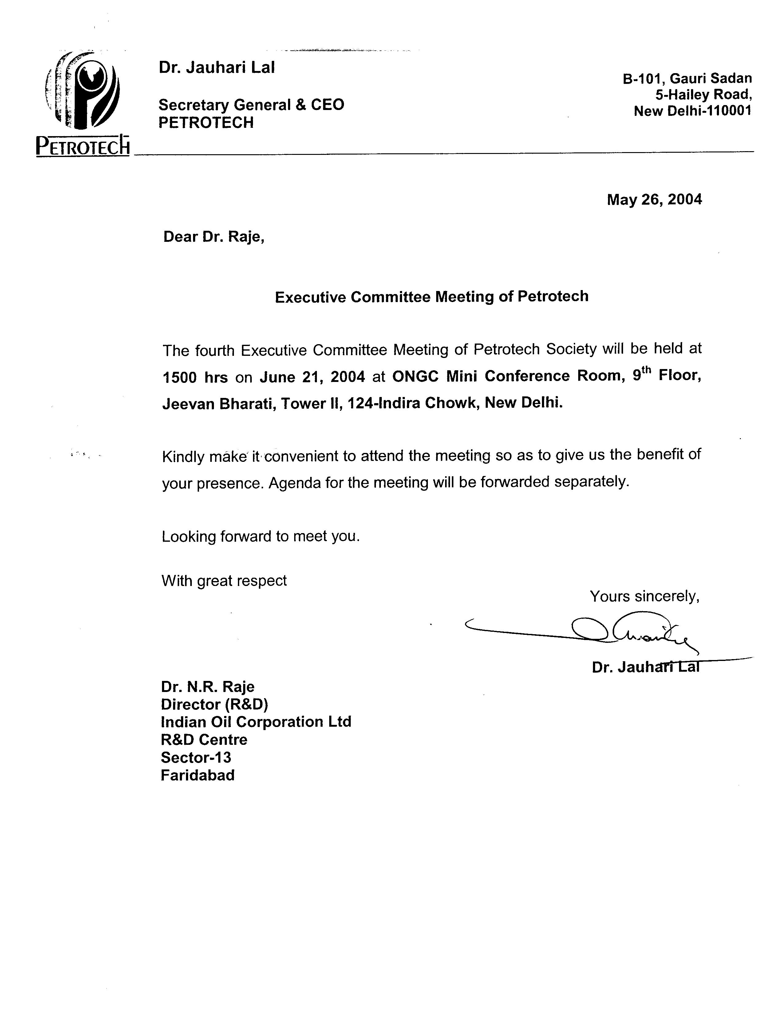

(R.P. Singh)

