Indian Telephone subscriber base reaches 723.28 million
New Delhi, 02 December, 2010 - http://telecomindiaonline.com/
- Wireless subscription reaches 687.71 Million
- Active wireless subscribers in VLR 482.89 Million
- Wireline subscription declines to 35.57 Million
- 17.10 Million new additions in wireless
- Overall Tele-density reaches 60.99
- Broadband subscription is 10.29 million
The number of telephone subscribers in India increased to 723.28 Million at the end of September 2010 from 706.37 Million in August-2010, thereby registering a growth rate of 2.39 %. With this, the overall Tele-density in India reaches 60.99
Wireless Segment (GSM, CDMA & FWP)
Wireless subscriber base increased from 670.60 Million in August-2010 to 687.71 Million at the end of September-2010 registering a growth of 2.55%. Wireless Tele-density stands at 57.99. Detailed statistics is at Annexure-I.
Out of the total 687.71 million wireless subscribers, 482.89 million subscribers were active subscribers in VLR on the last working day of the month i.e, 30th September 2010. The total active VLR numbers excludes the CDMA VLR figure of BSNL, as the service provider has not provided the VLR figures corresponding to their total CDMA subscriber base of 5.78 million. The proportion of VLR subscribers is approximately 70% of the total wireless subscriber base reported by the service providers.
Wireless Service: Service Providers’ share in net additions during the month of September 2010
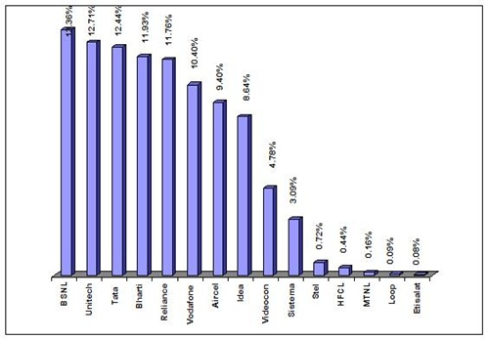

Service Provider wise Market Share as on 30-09-2010
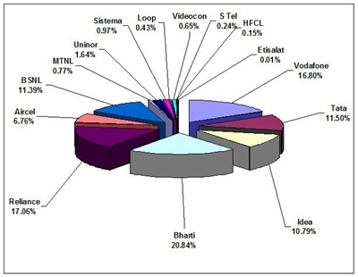
Wireline Segment
Wireline subscriber base declined from 35.77 Million in August-2010 to 35.57 Million at the end of September-2010. BSNL/MTNL, two PSU operators hold 83.48% of the Wireline market share. Overall Wireline teledensity is 3.00.
Service Provider wise Market Share as on 31-08-2010
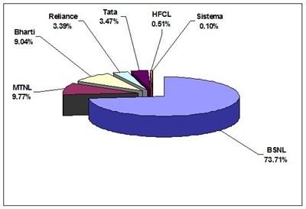
Category wise Net Additions during the Month of September - 2010
Category | Net Addition
Category | Wireline | Wireless
Circle A | -24253 | 5217056
Circle B | -167475 | 7243335
Circle C | -20370 | 2535265
Metro | 13639 | 2109217
All India | -198492 | 17104873
Category-wise Growth Rate in Access Service
Category | Monthly rate of growth  (August 2010 to September 2010) |  | Yearly rate of growth  (September 2009 to September 2010)
Category | Wireline | Wireless | Wireline | Wireless
Circle A | -0.18% | 2.15% | -3.01% | 41.30%
Circle B | -1.41% | 2.80% | -9.81% | 49.92%
Circle C | -0.66% | 2.88% | -5.64% | 54.33%
Metro | 0.19% | 2.58% | 1.96% | 38.43%
All India | -0.55% | 2.55% | -4.66% | 45.79%
Broadband (≥ 256 Kbps download)
Total Broadband subscriber base has increased from10.08 million in Aug-2010 to 10.29 million in Sep-2010, there by showing a growth of 2.08 %

