Indian Telecom market added more than 50 million users in QE Sep-10
New Delhi, 12 January, 2010-http://telecomindiaonline.com/
The TRAI today released the “Indian Telecom Services Performance Indicator Report” for the Quarter ending September 2010. This Report provides a broad perspective of the Telecom Services and presents the key parameters and growth trends for the Telecom Services as well as Cable TV, DTH & Radio Broadcasting services in India for the period covering July to September 2010, and is compiled on the basis of information furnished by the Service Providers.
Quarter performance summary
The number of telephone subscribers in India increased from 671.69 million in Jun-10 to 723.28 million at the end of Sep-10, registering a sequential growth of 7.68% over the previous quarter as against 8.11% during the QE Jun-10. This reflects year-on-year (Y-O-Y) growth of 42.09% over the same quarter of last year. The overall Teledensity in India has reached 60.99 as on 30th September 2010.
Trends in Telephone subscribers and Teledensity in India
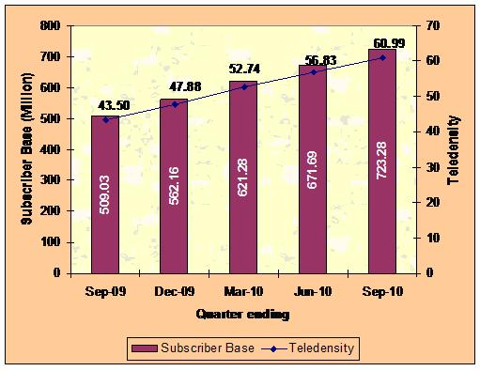
Subscription in Urban Areas grew from 452.59 million in Jun-10 to 487.07 million at the end of Sep-10, taking the Urban Teledensity from 128.20 to 137.25. Rural subscription increased from 219.09 million to 236.21 million, and the Rural Teledensity increased from 26.43 to 28.42. The share of Rural subscribers has increased slightly to 32.66% in total subscription from 32.62% in Jun-10.
About 66.83% of the total net additions have been in Urban areas as compared to 63.47% in the previous quarter. Rural subscription recorded a decline in rate of growth during the quarter, from 9.18% in Jun-10 to 7.81% in Sep-10. Rate of growth for Urban subscription increased marginally from 7.61% in QE Jun-10 to 7.62% in QE Sep-10.
Composition of Telephone Subscribers
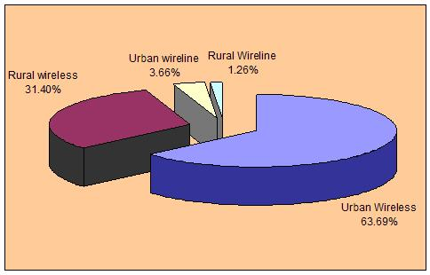
With 52.21 million net additions during the quarter, total wireless (GSM + CDMA) subscriber base registered a growth of 8.21% over the previous quarter and increased from 635.51 million at the end of Jun-10 to 687.71 million at the end of Sep-10. The year-on-year (Y-O-Y) growth over the same quarter of last year is 45.79%. Wireless Teledensity reached 57.99.
Wireline subscriber base further declined from 36.18 million at the end of Jun-10 to 35.57 million at the end of Sep-10, bringing down the wireline Teledensity from 3.06 in Jun-10 to 3.00 end of Sep-10.
Internet subscribers increased from 16.72 million at the end of Jun-10 to 17.90 million at the end of Sep-10, registering a quarterly growth rate of 7.02%. Top 10 ISPs together hold 95% of the total Internet subscriber base.
Number of Broadband subscribers increased from 9.47 million at the end of Jun-10 to 10.30 million at the end of Sep-10, registering a quarterly growth of 8.79% and Y-O-Y growth of 42.93%. The growth in the number of Broadband subscribers during the quarter and also on Y-O-Y basis is more or less similar to the growth in the over all telephone subscribers base.
Share of Broadband subscription in total Internet subscription increased from 56.7% in Jun-10 to 57.6% in Sep-10. 86.89% of the Broadband subscribers are using Digital Subscriber Line (DSL) technology.
Trends in Internet/Broadband subscription
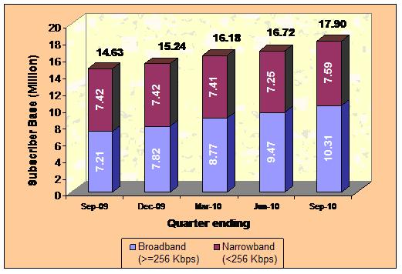
Average Revenue Per User (ARPU) for GSM-Full Mobility service declined by 10.16%, from `122 in QE Jun-10 to `110 in QE Sep-10, with Y-O-Y decrease of 33.1%.
MOU per subscriber for GSM – full mobility service declined by 8.1%, from 401 in QE Jun-10 to 368 in QE Sep-10. The Outgoing MOUs (177) declined by 9.35% and Incoming MOUs (191) by 6.97%.
1ARPU for CDMA – full mobility service declined by 1.34%, from `74 in QE Jun-10 to `73 in QE Sep-10. ARPU for CDMA has declined by 17.5% on Y-O-Y basis.
MOU per subscriber for CDMA-full mobility service declined by 5.26% from 299 in QE Jun-10 to 283 in QE Sep-10. The Outgoing MOUs (138) marginally declined by 5.21% while Incoming MOUs (145) declined by 5.30%.
Gross Revenue (GR) and Adjusted Gross Revenue (AGR) of Telecom Sector for the QE Sep-10 has been `41,895.95 Crore and `29,736.20 Crore respectively. There has been an increase of 1.22% in GR while AGR declined by 2.45% as compared to previous quarter. The year-on-year (Y-O-Y) growth for Sep-10 over the same quarter in last year has been 7.83% and 2.13%. Pass-through charges accounted for 29.02% of the GR for the quarter ending Sep-10. The quarterly and the year-on-year (Y-O-Y) growth rates of pass-through charges for QE Sep-10 are 11.45% and 24.85% respectively.
Average licence fee as percentage of AGR is 8.31% in QE Sep-10 as against 8.10% in previous quarter. The quarterly and the year-on-year (Y-O-Y) growth rates of the average licence fee for QE Sep-10 are 0.19% and 0.91% respectively.
Access services contributed 76.39% of the total revenue of telecom services. In Access services GR, AGR & License Fee declined by 1.51%, 4.46% & 0.84% respectively, and Spectrum charges increased by 14.93% in the quarter ending Sep-10 vis-à-vis previous quarter.

